**SQL Assignment 2**

1. For an online purchasing database, create entity relationship diagrams. Create a database object from your entity diagram.

Sol:- 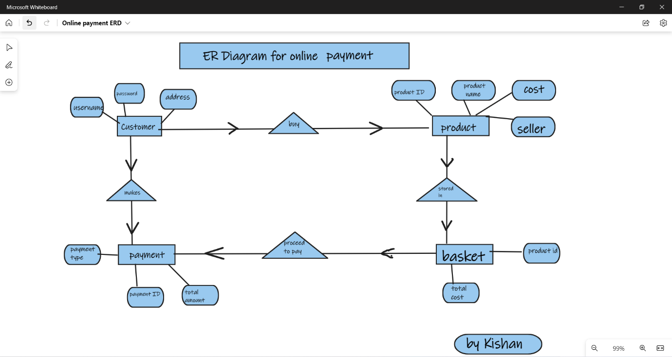

1. Create a SQL store process to register the use of the database, complete it with proper validation and transaction rollback and commit.

Sol:- In sql store procedure are saved code which are use-full when we want a particular code to run multiple times. We can make use of this concept and we can give arguments in this store procedure so based on requirement that code act accordingly.

1. List the SQL aggregate function and demonstrate how to utilize it.

Sol:- There are 5 SQL aggregate functions.

* AVG :- calculates the average from a set of values.
* COUNT :- counts rows in a specified table.
* MAX :- gets the maximum from a set of values.
* MIN :- gets the minimum from a set of values.
* SUM :- gets the sum of all values.

Demonstration for aggregate function.

I will be using **sales** database which has **profit** column

* + use sales
  + select avg(profit) as `Avg_Of_Profit` from sales
  + select count(*) as `Total_Count` from sales
  + select max(profit) as `Max_Profit` from sales
  + select min(profit) as `Min_Profit` from sales
  + select sum(profit) as `Total_Profit`from sales

1. In SQL, create a pivot query.

Sol:- In SQL, Pivot is relational operation that is used to transform one table into another in order to achieve more simple view of the entire table.

* Pivot query will convert row data of table into column data.

1. With an example, describe how to join in SQL.

**Sol:- Join** clause is used to combine two or more tables based on a related columns (column name might not be same) between them.

Example:-

* **Creating tables.**

create database CDB;

use CDB;

create table Customers (

CustomerID int not null,

CustomerName varchar(20),

ContactName varchar(20),

Address varchar(50),

City varchar(10),

PostalCode int,

Country varchar(10),

primary key (Customerid)

);

select * from Customers;

create table orders (

OrderID int not null,

CustomerID int,

EmployeeID int,

OrderDate datetime,

ShipperID int,

primary key (orderid)

);

Select * from orders;

insert into customers values (1, 'kishan', 'kishan', 'TS', 'Adilabad', '504346', 'INDIA');

insert into customers values (2,'siri chandana','siri','AP','Nellore','524002','INDIA');

insert into customers values (3,'Nikitha','glory','CG','bhilai','491002','INDIA');

insert into customers values (4,'Gayathri','Gayi','AP','Dachapalli','522414','INDIA');

insert into orders values(901,1,1,sysdate(),92801);

insert into orders values(902,2,1,sysdate()-10,92801);

insert into orders values(903,3,4,sysdate()-20,92801);

insert into orders values(904,4,5,sysdate()-12,92801);

insert into orders values(905,1,6,sysdate()-23,92801);

* **Join operations**

**Left join :-**

select c.customerid,o.orderid

from customers c

left join orders o

on c.customerid=o.customerid;

**Right join :-**

select c.customerid,o.orderid

from customers c

right join orders o

on c.customerid=o.customerid;

**Inner join:-**

select c.customerid,o.orderid

from customers c

right join orders o

on c.customerid=o.customerid;

**Full outer joins:-**

select c.customerid,c.customername,o.orderid

from customers c

left join orders o

on c.customerid=o.customerid

union

select c.customerid,c.customername,o.orderid

from customers c

right join orders o

on c.customerid=o.customerid;

1. How to locate the 4th highest value in a column in a row. Create your table

Sol:- I have already created the customer table with 4 records in **question 5**

desc customers

|  |  |  |  |  |  |
| --- | --- | --- | --- | --- | --- |
| CustomerID | int | NO | PRI |  |  |
| CustomerName | varchar(20) | YES |  |  |  |
| ContactName | varchar(20) | YES |  |  |  |
| Address | varchar(50) | YES |  |  |  |
| City | varchar(10) | YES |  |  |  |
| PostalCode | int | YES |  |  |  |
| Country | varchar(10) | YES |  |  |  |

**Inserting more records in customers**

* insert into customers values (5,'Rushika S','Rushika','MH','Pune','411014','INDIA');
* insert into customers values (6,'Vinay','Vinay','AP','Visakpatam','500020','INDIA');
* insert into customers values (7,'Rosmin','Rosmin','Kerla','Elettil','673572','INDIA');
* insert into customers values (8,'Mallika cr', 'lady cr', 'TS', 'Hyderabad', '500008', 'INDIA');
* insert into customers values(9,'Gowtham','beauty','AP','Guntur','522001','INDIA');
* insert into customers values(10,'Kusuma','Aishu','AP','Tenali','522202','INDIA');

**code:-**

select * from customers order by customerid desc

limit 1

offset 3;

**output:-**

|  |  |  |  |  |  |  |
| --- | --- | --- | --- | --- | --- | --- |
| 7 | Rosmin | Rosmin | Kerla | Elettil | 673572 | INDIA |
|  |  |  |  |  |  |  |